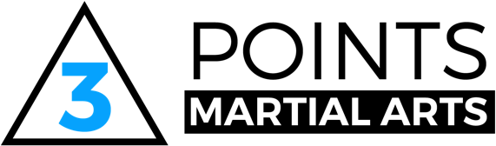

Three Points Martial Arts Equity Policy Statement

Three Points Martial Arts respects the rights, dignity and worth of every person and will treat everyone equally within the context of their sport, regardless of age, ability, gender, race, ethnicity, religious belief, sexuality or social/economic status.

Three Points Martial Arts is committed to ensuring that equity is incorporated across all aspects of its development. In doing so it acknowledges and adopts the following Sport England definition of sports equity:

Sports equity is about fairness in sport, equality of access, recognising inequalities
and taking steps to address them. It is about changing the culture and structure of
sport to ensure that it becomes equally accessible to all members of society,
whatever their age, ability, gender, race, ethnicity, sexuality or socio-economic status.

Three Points Martial Arts is committed to everyone having the right to enjoy their sport in an
environment free from threat of discrimination, intimidation, harassment and abuse.

All Club members have a responsibility to challenge discriminatory behaviour and
promote equality of opportunity.

Three Points Martial Arts will deal with any incidence of discriminatory behaviour seriously, according to our code of conduct and disciplinary procedures.

